**Automated test cases Id’s:**

* **Failed**
  + **Additional documents**
  + **Candidate correlations – Kendo Bubbles**
  + **Candidate correlations – Kendo Points**
  + **Candidate Entry Exams**
* **Passed**
  + **Additional documents**
  + **Candidate correlations – Kendo Bubbles**
  + **Candidate correlations – Kendo Points**
  + **Candidate Entry Exams**
    1. 389
    2. 390
    3. 391
    4. 399
    5. 400

**Manual test cases Id’s:**

* **Failed**
  + **Additional documents**
    1. 346 – BugID 2819
    2. 745 – BugID 2819
    3. 746 – BugID 2819
  + **Candidate correlations – Kendo Bubbles**
  + **Candidate correlations – Kendo Points**
  + **Candidate Entry Exams**
    1. 392 – bug no date starting error message-passed
    2. 393 - bug no date ending error message-passed
    3. 395 – bug no allowed IP error message-passed-not required
    4. 753 – bug no error message for upper bound for limit candidates count
    5. 757 – bug change date to existing exam to valid does not update details
  + **Candidates**
    1. 295 – BugID 2769
    2. 296 – BugID 2769
    3. 292 – BugID 2769
    4. 742 – BugID 2769
  + **[Front-End] Application for Software Academy**
    1. 760 – BugID 2769
    2. 822 – bug no validation for unchosen city=passed
    3. 823 - bug no validation for unchosen university=paddes
* **Passed**
  + **Additional documents**
    1. 348
    2. 351
    3. 352
    4. 322
    5. 323
  + **Candidate correlations**
* **Kendo Bubbles**
  + - 1. 372
      2. 373
      3. 374
      4. 375
      5. 376
      6. 377
* **Kendo Points**
  1. 372
  2. 373
  3. 374
  4. 375
  5. 376
  6. 377
  + **Candidate Entry Exams**
    1. 394
    2. 396
    3. 755
    4. 758
  + **Candidates**
    1. 299
    2. 293
    3. 294
  + **[Front-End] Application for Software Academy**
    1. 761
    2. 764
    3. 765
    4. 766
    5. 767
    6. 768
    7. 805
    8. 806
    9. 807
    10. 808
    11. 809
    12. 810
    13. 813
    14. 814
    15. 815
    16. 816
    17. 817
    18. 818
    19. 819
    20. 820
    21. 821
    22. 824
    23. 825
    24. 826
    25. 827
    26. 828
    27. 829

**Test cases Id’s with impediment to run:**

* **Additional documents**

1. 349 – BugID 2769
2. 749 – BugID 2769
3. 751 – BugID 2769
4. 357 – BugID 2769
5. 358 – BugID 2769
6. 359 – BugID 2769

* **Candidate correlations – Kendo Bubbles**

1. 378 - BugID 2769
2. 379 - BugID 2769
3. 380 - BugID 2769

* **Candidate correlations – Kendo Points**

1. 382 - BugID 2769
2. 383 - BugID 2769
3. 384 - BugID 2769

* **Candidates**

1. 300 - BugID 2769
2. 743 - BugID 2769
3. 744 - BugID 2769
4. 312 - BugID 2769

**BugID 2769**

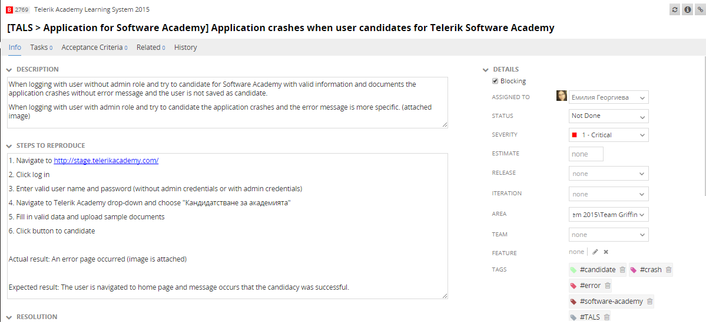

|  |  |
| --- | --- |
| **Module** | **Affected test cases count** |
| **Test cases with impediment to run** | |
| Candidates | 4 |
| Candidate correlations – Kendo Points/ Kendo Bubbles | 6 |
| Additional documents | 6 |
| **Test cases failed** | |
| Candidates | 4 |
| [Front-End] Application for Software Academy | 1 |
|  |  |
| **Priority 1** | 3 |
| **Priority 2** | 18 |
|  |  |
|  |  |
| **Total** | **21** |

**BugID 2819**

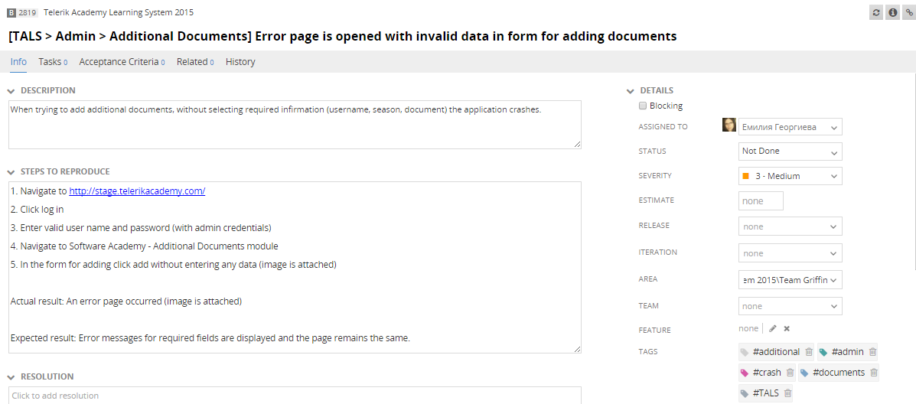

|  |  |
| --- | --- |
| **Module** | **Affected test cases count** |
| **Test cases with impediment to run** | |
| **Test cases failed** | |
| Additional documents | 3 |
| **Priority 2** | 2 |
| **Priority 3** | 1 |
| **Total** | **3** |